**ФПИиКТ**

**Рабочий протокол и отчет по**

**домашней работе №4**

**Вариант №6**

Ибадуллаев Алибаба Эльбрус оглы

Группа: P3215

Преподаватель: Малышева Татьяна Алексеевна

Санкт-Петербург

2022г.

**1. Цель лабораторной работы**: Найти функцию, являющуюся наилучшим приближением заданной табличной функции по методу наименьших квадратов.

**Для исследования использовать:**

1. линейную функцию;
2. полиномиальную функцию 2-й степени;
3. полиномиальную функцию 3-й степени;
4. экспоненциальную функцию;
5. логарифмическую функцию;
6. степенную функцию.
7. **Методика проведения исследования:**
8. Вычислить меру отклонения: $S=\sum_{i=1}^{n}{{[φ\left(x_{i}\right)-y_{i}]}^{2}}$ для всех исследуемых функций.
9. Уточнить значения коэффициентов эмпирических функций, минимизируя функцию S.
10. Сформировать массивы предполагаемых эмпирических зависимостей ($φ\left(x_{i}\right), ε_{i})$.
11. Определить среднеквадратичное отклонение для каждой аппроксимирующей функции. Выбрать наименьшее значение и, следовательно, наилучшее приближение.
12. Построить графики полученных эмпирических функций.

|  |  |  |
| --- | --- | --- |
| 6 |  |  |

[*https://www.desmos.com/calculator/gtwet8sd99*](https://www.desmos.com/calculator/gtwet8sd99)

1. **Вычислительная реализация задачи:**

x0 = 0.0 y0 = 0.00

x1 = 0.2 y1 = 0.40

x2 = 0.4 y2 = 0.78

x3 = 0.6 y3 = 1.06

x4 = 0.8 y4 = 1.14

x5 = 1.0 y5 = 1.00

x6 = 1.2 y6 = 0.78

x7 = 1.4 y7 = 0.58

x8 = 1.6 y8 = 0.42

x9 = 1.8 y9 = 0.31

x10 = 2.0 y10 = 0.24

SX = 11.0

SXX = 15.4

SXXX = 24.2

SXXXX = 40.532

SY = 6.707

SXY = 6.395

SXXY = 7.546

FIRST APPROXIMATION(linear)

<<RESULTS>>

<<Triangle Matrix>>

A = [11.0, 11.0]

[0.0, 4.4]

B = [6.71, -0.312]

X = [0.6809, -0.0709]

S = 1.351

Theta = 0.3504

SECOND APPROXIMATION(2nd polynomial)

<<INPUT MATRIX>>

A = [11.0, 11.0, 15.4]

[11.0, 15.4, 24.2]

[15.4, 24.2, 40.5328]

B = [6.71, 6.398, 7.5516]

<<Iteration №1>>

A = [11.0, 11.0, 15.4]

[0.0, 4.4, 8.79]

[0.0, 8.799, 18.9728]

B = [6.71, -0.312, -1.8423]

<<Iteration №2>>

A = [11.0, 11.0, 15.4]

[0.0, 4.4, 8.799]

[0.0, 0.0, 1.3728]

B = [6.71, -0.312, -1.2183]

<<RESULTS>>

<<Triangle Matrix>>

A = [11.0, 11.0, 15.4]

[0.0, 4.4, 8.799]

[0.0, 0.0, 1.372]

B = [6.71, -0.312, -1.2183]

X = [0.1483, 1.704, -0.887]

S = 0.269

Theta = 0.156

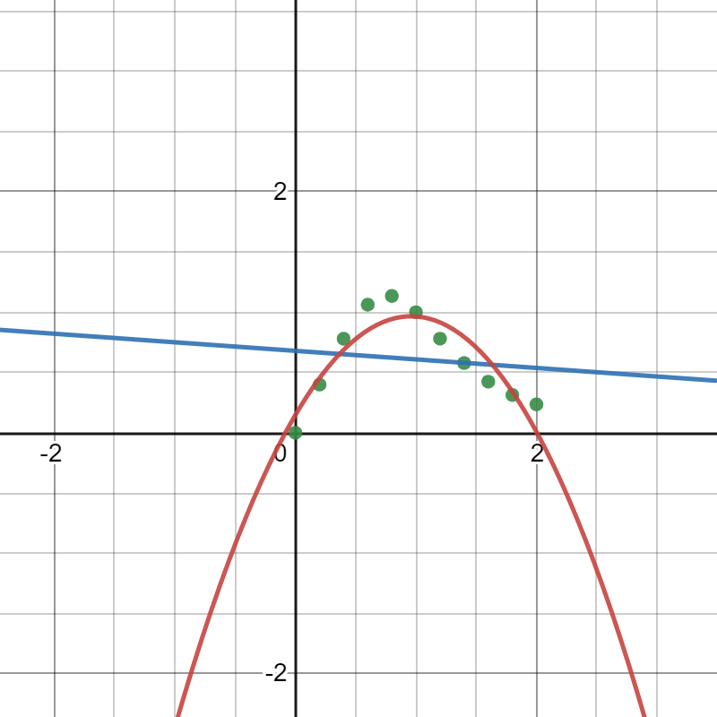

1. **Программная реализация задачи:**
   1. Предусмотреть ввод исходных данных из файла/консоли (таблица *y=f(x)* должна содержать 10 - 12 точек).
   2. Реализовать метод наименьших квадратов, исследуя все функции п.1.
   3. Предусмотреть вывод результатов в файл/консоль.
   4. Для линейной зависимости вычислить коэффициент корреляции Пирсона.
   5. Программа должна отображать наилучшую аппроксимирующую функцию.
   6. Организовать вывод графиков функций, графики должны полностью отображать весь исследуемый интервал (с запасом).
2. **Основные рабочие формулы**



1. **Листинг программы**

**Основной код:**

double[] arr1 = {n, SX, SX,SXX,SY, SXY};  
double[] arr2 = {n, SX, SXX,SX, SXX, SXXX, SXX, SXXX, SXXXX, SY, SXY, SXXY};  
double[] arr3 = {n, SX, SXX, SXXX, SX, SXX, SXXX, SXXXX, SXX, SXXX, SXXXX, SXXXXX, SXXX, SXXXX, SXXXXX, SXXXXXX, SY, SXY, SXXY, SXXXY};  
double[] arr4 = {n, SLN_X, SLN_X,SLN_XX, SLN_Y, SLN_XY};  
double[] arr5 = {n, SX, SX,SXX, SLN_Y, SXLN_Y};  
double[] arr6 = {n, SLN_X, SLN_X,SLN_XX, SY, SYLN_X};  
  
System.*out*.println("FIRST APPROXIMATION(linear)");  
double[] x1 = *gaussianMethod*(arr1, 2);  
DoubleFunction<Double> f_X1 = (x) -> x1[0] + x1[1]*x;  
thetas.put(1,*io*.showResults(points, f_X1));  
  
double SX_X_AVG_Y_Y_AVG = 0;  
double SX_X_AVG2 = 0;  
double SY_Y_AVG2 = 0;  
for (double key: points.keySet()){  
 SX_X_AVG_Y_Y_AVG += ((key-AVG_X)*(points.get(key)-AVG_Y));  
 SX_X_AVG2 += Math.*pow*(key-AVG_X,2);  
 SY_Y_AVG2 += Math.*pow*(points.get(key)-AVG_Y,2);  
}  
R = SX_X_AVG_Y_Y_AVG/Math.*sqrt*(SX_X_AVG2*SY_Y_AVG2);  
System.*out*.format("r = %.3f\n", R); // Pirson coefficient  
*io*.showResultsLinear(points, f_X1);  
  
  
System.*out*.println("SECOND APPROXIMATION(2nd polynomial)");  
double[] x2 = *gaussianMethod*(arr2, 3);  
DoubleFunction<Double> f_X2 = (x) -> x2[0] + x2[1]*x + x2[2]*x*x;  
thetas.put(2,*io*.showResults(points, f_X2));  
  
System.*out*.println("THIRD APPROXIMATION(3rd polynomial)");  
double[] x3 = *gaussianMethod*(arr3, 4);  
DoubleFunction<Double> f_X3 = (x) -> x3[0] + x3[1]*x + x3[2]*x*x + x3[3]*x*x*x;  
thetas.put(3,*io*.showResults(points, f_X3));  
  
System.*out*.println("FOURTH APPROXIMATION(power function)");  
double[] x4 = *gaussianMethod*(arr4, 2);  
DoubleFunction<Double> f_X4 = (x) -> Math.*exp*(x4[0])*Math.*pow*(x,x4[1]);  
thetas.put(4,*io*.showResults(points, f_X4));  
  
System.*out*.println("FIFTH APPROXIMATION(exponential function)");  
double[] x5 = *gaussianMethod*(arr5, 2);  
DoubleFunction<Double> f_X5 = (x) -> Math.*exp*(x5[0])*Math.*exp*(x*x5[1]);  
thetas.put(5,*io*.showResults(points, f_X5));  
  
System.*out*.println("SIXTH APPROXIMATION(logarithm function)");  
double[] x6 = *gaussianMethod*(arr6, 2);  
DoubleFunction<Double> f_X6 = (x) -> x6[0] + x6[1]*Math.*log*(x);  
thetas.put(6,*io*.showResults(points, f_X6));  
  
for(int tht : thetas.keySet()){  
 if (thetas.get(tht)<theta) {  
 theta = thetas.get(tht);  
 min = tht;  
 }  
}  
System.*out*.print("THE BEST APPROXIMATION FUNCTION IS: ");  
switch (min){  
 case 1:  
 System.*out*.println("Linear");  
 break;  
 case 2:  
 System.*out*.println("Polynom 2nd");  
 break;  
 case 3:  
 System.*out*.println("Polynom 3rd");  
 break;  
 case 4:  
 System.*out*.println("Power function");  
 break;  
 case 5:  
 System.*out*.println("Exponential function");  
 break;  
 case 6:  
 System.*out*.println("Logarithm function");  
 break;  
}

**Метод Гаусса (для вычисления коэффициентов формул апроксимаций):**

public static double[] gaussianMethod(double [] arr_res, int n){  
 double[] x = new double[n];  
 double [][] arr = new double[n][n];  
 double[] b = new double[n];  
 int stop = 0;  
 double c;  
 double s;  
 int swaps = 0;  
  
  
 // Fulling matrix by result array which has got from data input  
 for (int i = 0; i < n; i++){  
 for (int k = 0; k < n; k++){  
 arr[i][k] = arr_res[k+(i*n)];  
 }  
 b[i] = arr_res[(n*n)+i];  
 }  
 double [][] arr_copy = new double[n][n];  
 double [] b_copy = new double[n];  
  
 for (int i = 0; i < n; i++) {  
 System.*arraycopy*(arr[i], 0, arr_copy[i], 0, arr[i].length);  
 }  
  
 System.*arraycopy*(b, 0, b_copy, 0, arr.length);  
  
 System.*out*.println("\t<<INPUT MATRIX>>");  
 *io*.showExtendedMatrix(arr, b);  
  
 // straight stroke (process of exception an elements of matrix to get triangle-matrix)  
 for(int i = 0; i < n - 1 ; i++){  
 while (arr[i][i] == 0 ){  
 if (stop == n - i) {  
 System.*err*.println("The error in swapping lines!");  
 System.*exit*(0);  
 }  
 *swapLines*(arr, b, i);  
 stop++;  
 swaps++;  
 }  
  
 for (int k = i+1; k < n; k++){  
 c = arr[k][i] / arr[i][i];  
 arr[k][i] = 0;  
 for (int j = i+1; j < n; j++){  
 arr[k][j] = arr[k][j] - c * arr[i][j];  
 }  
 b[k] = b[k] - c * b[i];  
 }  
 stop = 0;  
 System.*out*.println();  
 System.*out*.println("\t<<Iteration №" + (i+1)+">>");  
 *io*.showExtendedMatrix(arr, b);  
 }  
  
  
 // reverse stroke (process of getting an unknown variables)  
 for (int i = n - 1 ; i >= 0 ; i--){  
 s = 0;  
 for (int j = i+1; j<n; j++){  
 if (Double.*isNaN*(x[j])) s=s+0;  
 else s = s + arr[i][j]*x[j];  
 }  
 if (Double.*isInfinite*(s)) {  
 System.*err*.println("This system has no solution!\nBecause: "+"0!="+b[i+1]);  
 System.*exit*(-1);  
 }  
 x[i] = (b[i] - s)/arr[i][i] == -0 ? 0:(b[i] - s)/arr[i][i] ;  
 }  
 System.*out*.println("_____________________________________________________");  
 System.*out*.print("X =\t");  
 System.*out*.println(Arrays.*toString*(x));  
  
 return x;  
}

1. **Анализ результатов работы: апробация и тестирование.**

**Входные данные:**

7

1.1 2.73

2.3 5.12

3.7 7.74

4.5 8.91

5.4 10.59

6.8 12.75

7.5 13.43

**Выходные данные:**

You has selected file: input.txt

SX = 31,300

SXX = 172,090

SXXX = 1049,047

SXXXX = 6779,433

SXXXXX = 45466,149

SXXXXXX = 312660,209

SY = 61,270

SXY = 328,123

SXXY = 1970,578

SXXXY = 12612,240

Sln(X) = 9,359

Sln(XX) = 14,374

Sln(Y) = 14,374

Sln(XY) = 9,359

FIRST APPROXIMATION(linear)

<<INPUT MATRIX>>

A = [7.0, 31.300000000000004]

[31.300000000000004, 172.09]

B = [61.269999999999996, 328.123]

<<Iteration №1>>

A = [7.0, 31.300000000000004]

[0.0, 32.13428571428568]

B = [61.269999999999996, 54.15857142857135]

_____________________________________________________

X = [1.216788476927183, 1.6853827687383294]

S = 0,473

Theta = 0,260

_____________________________________________________

r = 0,997

_____________________________________________________

x0 = 1.1 y0 = 2,73 phi0 = 3,07

x1 = 2.3 y1 = 5,12 phi1 = 5,09

x2 = 3.7 y2 = 7,74 phi2 = 7,45

x3 = 4.5 y3 = 8,91 phi3 = 8,80

x4 = 5.4 y4 = 10,59 phi4 = 10,32

x5 = 6.8 y5 = 12,75 phi5 = 12,68

x6 = 7.5 y6 = 13,43 phi6 = 13,86

_____________________________________________________

SECOND APPROXIMATION(2nd polynomial)

<<INPUT MATRIX>>

A = [7.0, 31.300000000000004, 172.09]

[31.300000000000004, 172.09, 1049.047]

[172.09, 1049.047, 6779.4325]

B = [61.269999999999996, 328.123, 1970.5781]

<<Iteration №1>>

A = [7.0, 31.300000000000004, 172.09]

[0.0, 32.13428571428568, 279.55885714285694]

[0.0, 279.55885714285705, 2548.722771428571]

B = [61.269999999999996, 54.15857142857135, 464.2989142857143]

<<Iteration №2>>

A = [7.0, 31.300000000000004, 172.09]

[0.0, 32.13428571428568, 279.55885714285694]

[0.0, 0.0, 116.6427400906905]

B = [61.269999999999996, 54.15857142857135, -6.864766391037222]

_____________________________________________________

X = [0.37425996066520434, 2.197385944878237, -0.058852924628655164]

S = 0,069

Theta = 0,099

_____________________________________________________

THIRD APPROXIMATION(3rd polynomial)

<<INPUT MATRIX>>

A = [7.0, 31.300000000000004, 172.09, 1049.047]

[31.300000000000004, 172.09, 1049.047, 6779.4325]

[172.09, 1049.047, 6779.4325, 45466.14943]

[1049.047, 6779.4325, 45466.14943, 312660.209029]

B = [61.269999999999996, 328.123, 1970.5781, 12612.23965]

<<Iteration №1>>

A = [7.0, 31.300000000000004, 172.09, 1049.047]

[0.0, 32.13428571428568, 279.55885714285694, 2088.6937714285705]

[0.0, 279.55885714285705, 2548.722771428571, 19676.07825428571]

[0.0, 2088.6937714285705, 19676.078254285712, 155445.97928485717]

B = [61.269999999999996, 54.15857142857135, 464.2989142857143, 3430.081122857144]

<<Iteration №2>>

A = [7.0, 31.300000000000004, 172.09, 1049.047]

[0.0, 32.13428571428568, 279.55885714285694, 2088.6937714285705]

[0.0, 0.0, 116.6427400906905, 1505.0552897892667]

[0.0, 0.0, 1505.0552897892776, 19683.146104313142]

B = [61.269999999999996, 54.15857142857135, -6.864766391037222, -90.16736867964391]

<<Iteration №3>>

A = [7.0, 31.300000000000004, 172.09, 1049.047]

[0.0, 32.13428571428568, 279.55885714285694, 2088.6937714285705]

[0.0, 0.0, 116.6427400906905, 1505.0552897892667]

[0.0, 0.0, 0.0, 263.2368706868692]

B = [61.269999999999996, 54.15857142857135, -6.864766391037222, -1.5904631477168039]

_____________________________________________________

X = [0.6397716678970694, 1.9118771220533892, 0.019107039841767988, -0.006041946721091072]

S = 0,059

Theta = 0,092

_____________________________________________________

FOURTH APPROXIMATION(power function)

<<INPUT MATRIX>>

A = [7.0, 9.358854105460436]

[9.358854105460436, 15.255173133797939]

B = [14.373964419085535, 21.516072189105785]

<<Iteration №1>>

A = [7.0, 9.358854105460436]

[0.0, 2.742580252755989]

B = [14.373964419085535, 2.2983813440628005]

_____________________________________________________

X = [0.9329866476654225, 0.8380361310314192]

S = 0,154

Theta = 0,149

_____________________________________________________

FIFTH APPROXIMATION(exponential function)

<<INPUT MATRIX>>

A = [7.0, 31.300000000000004]

[31.300000000000004, 172.09]

B = [14.373964419085535, 71.80926739856876]

<<Iteration №1>>

A = [7.0, 31.300000000000004]

[0.0, 32.13428571428568]

B = [14.373964419085535, 7.537112210372001]

_____________________________________________________

X = [1.004647760759436, 0.23455048222905692]

S = 10,707

Theta = 1,237

_____________________________________________________

SIXTH APPROXIMATION(logarithm function)

<<INPUT MATRIX>>

A = [7.0, 9.358854105460436]

[9.358854105460436, 15.255173133797939]

B = [61.269999999999996, 97.41239291917515]

<<Iteration №1>>

A = [7.0, 9.358854105460436]

[0.0, 2.742580252755989]

B = [61.269999999999996, 15.495679913237879]

_____________________________________________________

X = [1.1988754276365259, 5.6500370035357905]

S = 4,200

Theta = 0,775

_____________________________________________________

THE BEST APPROXIMATION FUNCTION IS: Polynom 3rd

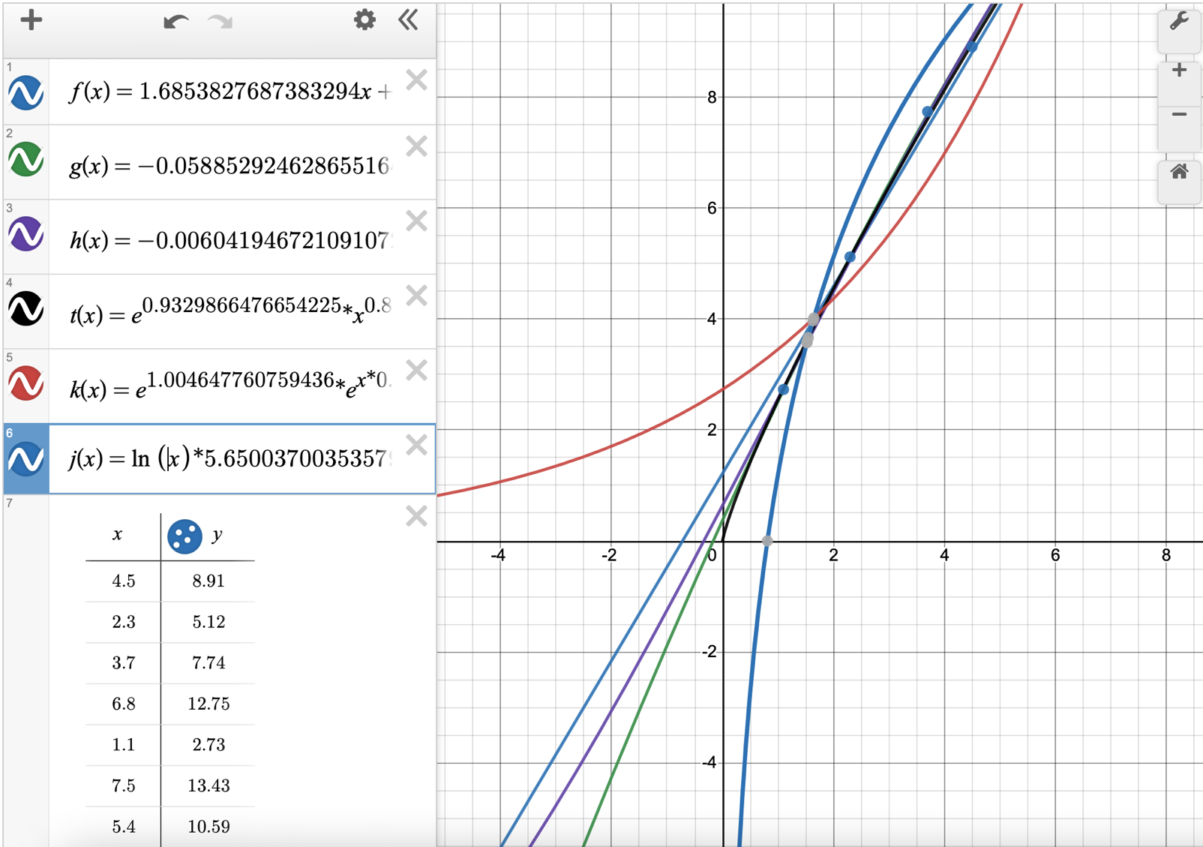

1. **Вывод работы:**

Я использовал разные апроксимирующие функции для входного набора точек, реализовав их с помощью метода Гаусса (для вычисления коэффициентов аппроксимирующих функций). Также смог вывести графики и вычислять ко/ффициенты Пирсона и т.д.